Page 2

Page 4

Una Voce of Orange County 980 Dorothea Rd. La Habra Hts. CA 90631

Phone: (562) 691-5246 E-mail: president@uvoc.org
Website: www.uvoc.org

The right hand of the Lord hath wrought strength: the right hand of the Lord hath exalted me: I shall not die, but live, and shall declare the works of the Lord.

OFFERTORY: PS 117. 16, 17

Déxtera Dómini fecit virtútem: déxtera Dómini exaltávit me: non móriar, sed vivam, et narrábo ópera Dómini.

Proper Prayers of the Mass

Third Sunday After Epiphany
Provided Courtesy of Una Voce Orange County

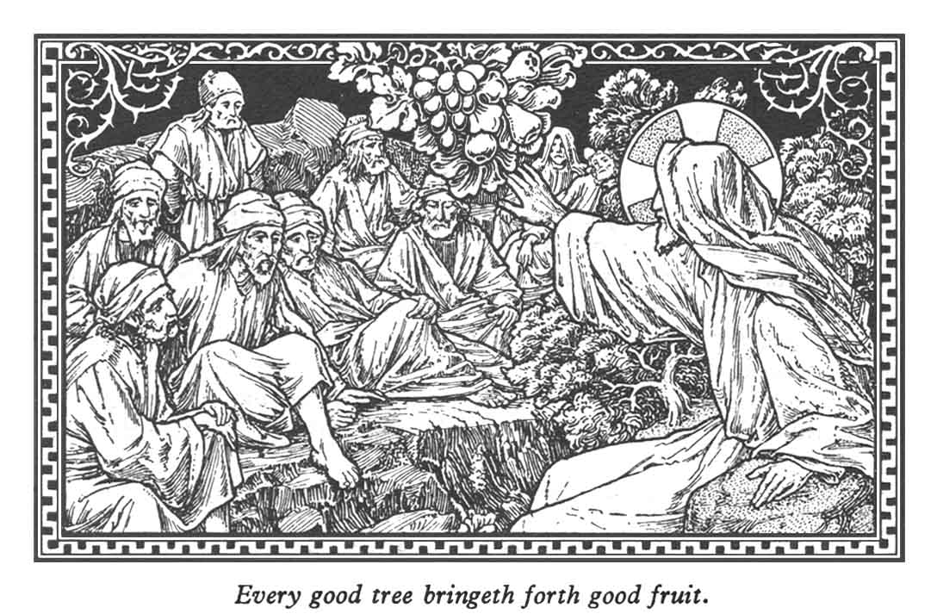

Hæc hóstia, Dómine, quǽ-sumus, emúndet nostra delíc-ta: et ad sacrifícium celebrán-dum, subditórum tibi córpora mentésque sanctíficet. Per Dó- minum.

May this offering, O Lord, we pray Thee, cleanse away our sins, and sanctify the bodies and minds of Thy servants for the celebration of this sacrifice. Through our Lord.

SECRET

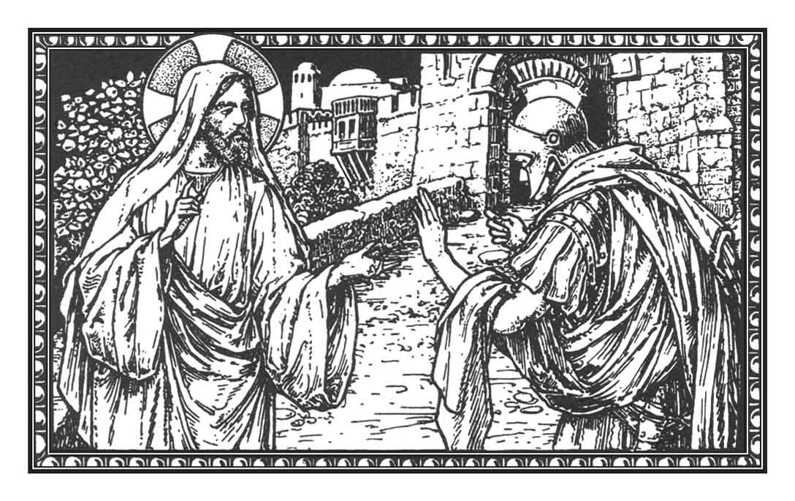
Only say the word and my servant shall be healed.

PREFACE OF THE MOST HOLY TRINITY
PLEASE SEE RED MISSAL

Mirabántur omnes de his, quæ procedébant de ore Dei.
COMMUNION: LUKE 4. 22

All wondered at these things which proceeded from the mouth of God. .

Quos tantis, Dómine, largíris uti mystériis: quǽsumus; ut efféctibus nos eórum veráciter aptáre dignéris. Per Dóminum nostrum. .

Vouchsafe, we pray Thee, O Lord, that we who of Thy bounty frequent these great mysteries, may be made worthy to enjoy their fruits. Through our Lord. .

POSTCOMMUNION

Omnípotens sempitérne Deus, infirmitátem nostram propí-tius réspice: atque ad prote-géndum nos, déxteram tuæ majestátis exténde. Per Dómi-num nostrum.

Almighty and eternal God, merci-fully look upon our infirmity, and stretch forth the right hand of Thy majesty to help and defend us. Through our Lord.

COLLECT

_{A}DORE God, all you His an- gels: Sion heard, and was glad: and the daughters of Juda rejoiced. Ps. The Lord hath reign-ed, let the earth rejoice: let many islands be glad. ℣. Glory be to the Father.

_{A}DORATE Deum, omnes . Angeli ejus: audívit, et lætáta est Sion: et exsulta-vérunt fíliae Judae. Ps. 96. 1. Dóminus regnávit, exsúltet terra: læténtur ínsulæ multæ. ℣. Glória Patri.

INTROIT: PS. 96. 7-8

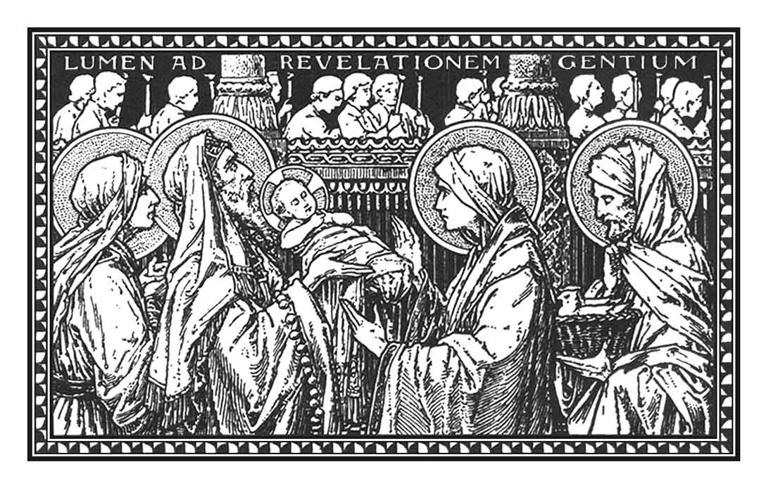
FEBRUARY 2

THE PURIFICATION OF THE BLESSED VIRGIN MARY

