Page 2

Page 4

Una Voce of Orange County 980 Dorothea Rd. La Habra Hts. CA 90631

Phone: (562) 691-5246 E-mail: president@uvoc.org

Website: www. uvoc.org

Proper Prayers of the Mass

Fourth Sunday of Advent
Provided Courtesy of Una Voce Orange County

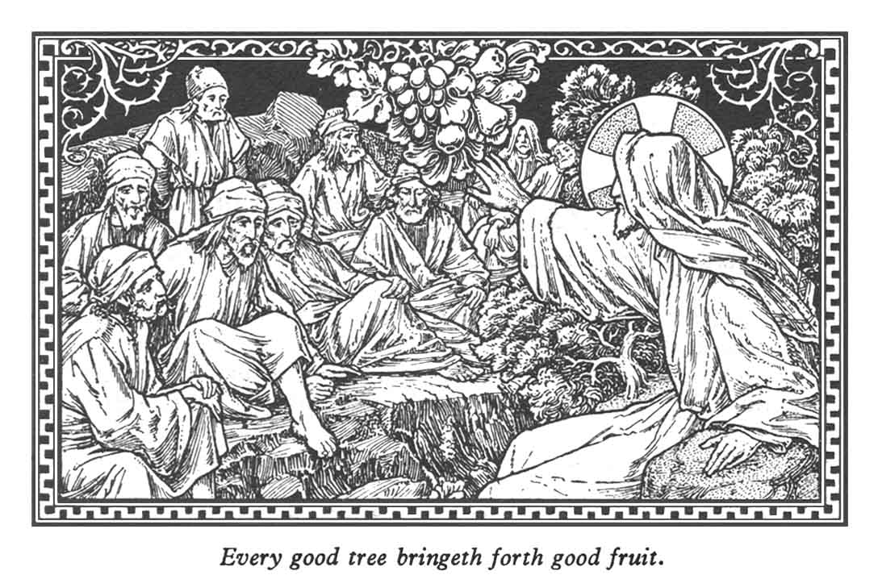

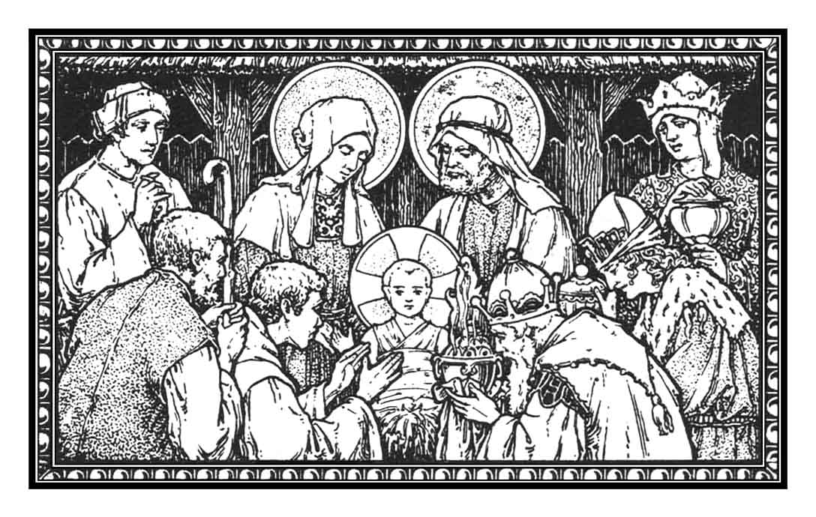

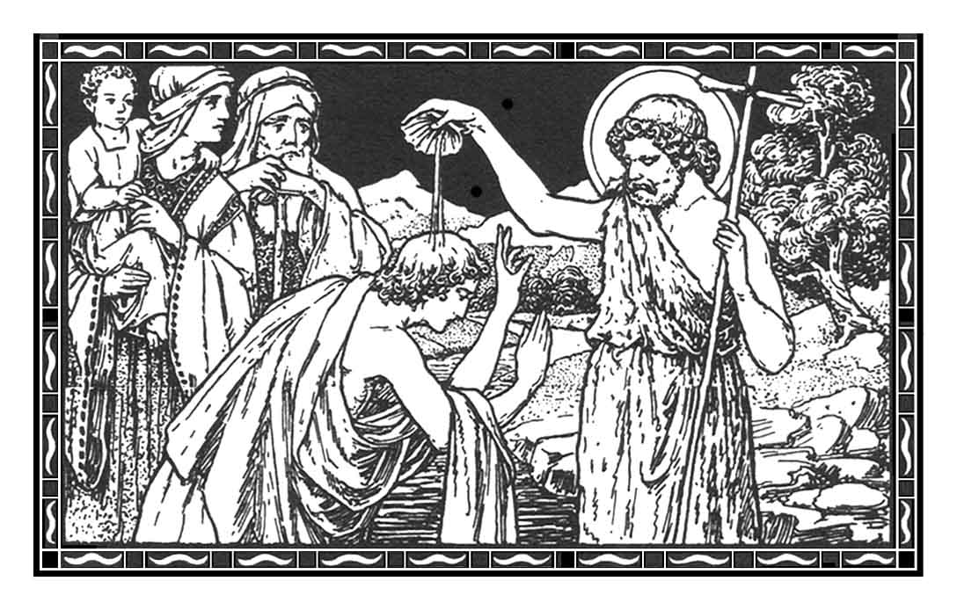
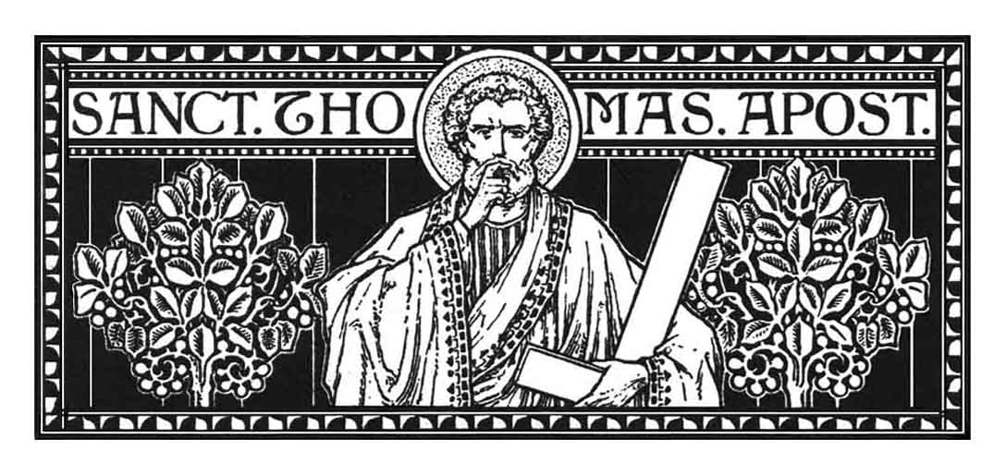
John teaching the Baptism of Penance.

Excita, quǽsumus, Dómine, poténtiam tuam, et veni: et magna nobis virtúte succúr- re; et per auxílium grátiæ tuæ, quod nostra peccáta præpé- diunt, indulgéntia tuæ propi- tiatiónis accéleret: Qui vivis. .Per Dóminum.

Stir up Thy power and come, we pray Thee, O Lord, and with great might succour us; that our deliverance, which our sins impe-de, may be hastened by the help of Thy grace and the forgive- ness of Thy mercy. Who livest. .
Almighty everlasting God, who in Thy beloved Son, King of the whole world, hast willed to restore all things anew; grant in Thy mercy that all the families of nations, rent asunder by the wound of sin, may be subjected to His most gentle rule. Who with Thee liveth. Through our Lord.

COLLECT

_{RD}ORATE, cæli, désuper, et
nubes pluant justum: a-periátur terra, et gérminet Sal-vatórem. Ps. 18. 2. Cæli enár-rant glóriam Dei: et opera mánuum ejus annúntiat fir-maméntum. ℣. Glória Patri. .Glória Patri.

INTROIT: APOC. 5. 12; 1. 26IS. 45. 8

_{TD}ROP down dew, ye heavens,
from above, and let the clouds rain the just: let the earth be opened and bud forth a Sav-iour. Ps. The heavens show forth the glory of God: and the firma-ment declareth the work of His hands. ℣. Glory be to the Father. .Lamb that was slain is worthy to receive power and divinity and wisdom and strength and honour; to Him be glory and empire for ever and ever. Ps. Give to the King, O God, Thy justice, and to the King’s Son Thy judgment. ℣. Glory be to the Father.

Sumptis munéribus, quǽsumus, Dómine: ut cum frequentatióne mystérii, crescat nostræ salútis efféctus. Per Dóminum.

Having received Thy gifts, we beseech Thee, O Lord, that with the frequentation of the myste- ry, the work of our salvation may increase. Through our Lord.Having received the food of immortality, we beseech Thee, O Lord, that we who glory in our service under the standard of Christ the King, may be able to reign with Him forever in His heavenly abode. Who with Thee.

POSTCOMMUNION

Ecce virgo concípiet et pá- riet fílium: et vocábitur no-men ejus Emmánu
el.

Sedébit Dóminus Rex in ætérnum: Dóminus benedícet pópulo suo in pace.

COMMUNION: IS. 7. 14PS. 28. 10, 11

Behold a Virgin shall conceive and bear a son: and His name shall be called Emmanuel.

DECEMBER 21OCTOBER 18

ST. THOMAS, APOSTLE LUKE, Evangelist

